Lab 3

Bước 1

Bước 2

Bước 3

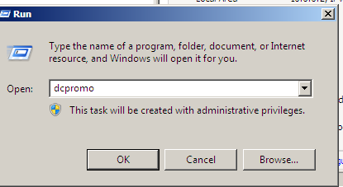

Cài firewall sophos

Bước 1

Bước 2

Bước 3

Bước 4

Bước 5

Kết quả kịch bản 1

Bước 1

Bước 2

Bước 3

Bước 4

Bước 5

Kết quả

